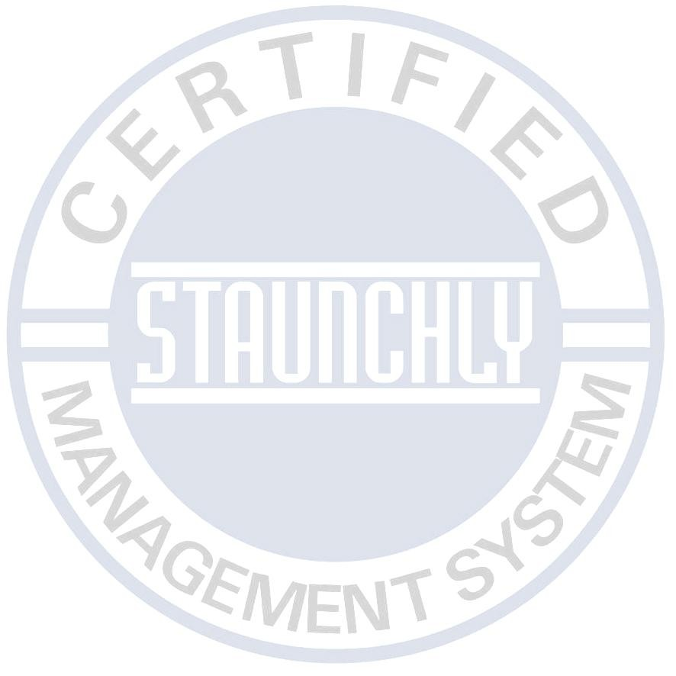

Please complete this questionnaire and forward it to Staunchly Management & System Services Pvt. Ltd. who will then provide you with a written proposal. Any information will be treated as confidential and will not be disclosed or discussed with any third party.
Company Name
Address
City | Riyadh | Code |  |  |  |  | Country
Tel Number |  |  |  |  |  |  | Contact Name
Fax Number |  | - |  |  |  |  | Position
Web Site |  |  |  |  |  |  | E-mail
Standard(s) to be assessed |  |  |  |  |  |  |  |  | 9001 exclusions
Accreditation Required |  |  |  |  |  |  |  |  | Other Information
Scope: Please describe what activities your organization carries out.
.
Please list any additional sites to be included in the scope of registration
Please list the number of employees in each area/site  (please use additional sheets if required ) |  |  |  | Full Time |  | Part Time |  | Shifts |  | Full Time  (Site 2) |  | Part Time  (Site 2) | Shifts  (Site 2)
Manufacturing/Service area
Quality Control/Technical
Administration
Storage/Warehouse
Other
Management
Total Employees (Full time equivalent)
Approx number of sub-contractors used on average if applicable. |  |  |  |  | Describe the type of work subcontracted if applicable.
Quality Management System ISO 9001
Number of Sites to be Audited?  Single  Multiple
Is the Clause” Design & Development” included in the Scope of Organization?  Yes  No Is there any process that affects the product conformity and is outsourced?  Yes  No
* Attach Statement of Non-Applicability (SONA) as per Annexure A of ISO 9001:2015  Yes  No Legal Obligations if any
Environmental Management System ISO 14001
Number of Sites to be Audited?  Single  Multiple Whether Initial Environmental Review (IER) available?  Yes  No Whether Register of Significant Aspects / Impacts available?  Yes  No Whether Legal Register available?  Yes  No Whether Environmental Management Program (EMP) available?  Yes  No
Has EMP been implemented?  Yes  No Attach List of Compliance Obligations  Yes  No

Occupational Health & Safety System ISO 45001
Number of Sites to be Audited?  Single  Multiple Have you identified Hazards?  Yes  No Detail all identified Critical occupational health and safety risks
Whether Incident/ Accident Register available?  Yes  No
Imp: Please furnish Table-1 and attach with Quotation request Form Attached as above  Yes  No
Food Safety Management System ISO 22000
Number of Sites to be Audited?  Single  Multiple
Have you implemented HACCP Principles?  Yes  No
Any seasonality issues?  Yes  No
Total No of HACCP Studies (As per ISO/TS 22003:2013) How many process lines are there in production Single
Any Prior Audits Conducted  Yes  No
If yes, attach audit findings
Information Security Management System ISO 27001/ Information Technology Service Management System ISO 20000-1Number of Sites to be Audited?  Single  Multiple
Has a Statement of Applicability been compiled?  Yes  No
No. of user = ……….... No. of sites = …….…….
No. of servers = …….……. No. of Workstations (PC + Laptops) = ………. ….. Any Prior Audits Conducted  Yes  No
If yes, attach audit findings……………………………………………………………………………………….
Energy Management System ISO 50001
Number of Sites to be Audited?  Single  Multiple Annual Energy Consumption=
Number of energy Sources=
Number of significant energies uses (SEUs) =
Medical Device Quality Management System ISO 13485
Number of Sites to be Audited?  Single  Multiple Outsourced process:
Critical activity:
Signature |  | Date
Please return this form to:
Staunchly Management & System Services Pvt. Ltd.
Local. Off.: Al Khobar - KSA
Corporate Office: United Kingdom
Call: +966-53-8996065; E Mail: info@gccssaudi.com ; www.gccssaudi.com

